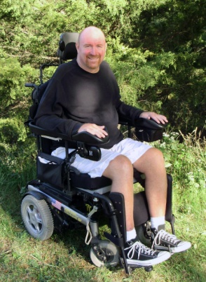 **16th ANNUAL MARK CAMERON GOLF CLASSIC**

•  **Friday, Sept 18th, 2020** at **Deer Creek Golf Course** Overland Park, KS

•  Check-in **(Lunch Provided) 12:00pm** with a Shot Gun Start **1:00pm**

•  Post party following with **Dinner, Drinks and Auction** begins at 6:00pm at

**Deer Creek Clubhouse**

•  Entries must be received by **August 28th, 2020**

•  Tournament is limited to 36 teams and is filled on a first come first serve basis

**ONLY** when full payment is received

•  For Questions, please email Josh @ [jcarr1112@yahoo.com](mailto:jcarr1112@yahoo.com)

•  Sponsorship Packages Available email Debbie [debbie@debbieswinney.com](mailto:debbie@debbieswinney.com)

•  **ONLINE PAYMENT AVAILABLE** FOR YOUR CONVIENENCE

More information at **www.teamcameron.org**



Make checks payable to: FBO Mark Cameron

Mail to: FBO Mark Cameron

c/o Josh Carr

12114 Juniper St.

Overland Park, KS. 66209

**$1500 PLATINUM LEVEL SPONSORSHIP**

$900 - Sponsorship only

**$1150 EAGLE LEVEL SPONSORSHIP**

$550 - Sponsorship only

**$950 BIRDIE LEVEL SPONSORSHIP**

$350 - Sponsorship only

**PAR GOLFERS**

$160 - Individual Golfer

$310 - 2 Golfers

$600 - 4 Golfers

I cannot golf but would like to donate:________

**SPONSORSHIP PACKAGES AVAILABLE**

**PLATINUM LEVEL SPONSORSHIP $1500**

Includes 4 Golfers and extra-large custom banner at registration/check-in, recognition in welcome packet, 4 golfers, opportunity to address golfers before shotgun start, company flyer, coupons, logo’d items, etc in golfer’s bag and a logo/web link on Teamcameron.org for a year.

**EAGLE LEVEL SPONSORSHIP $1150**

Includes 4 Golfers and custom banner at beverage stations, recognition in welcome packet, company flyer, coupons, logo’d items, etc in golfer’s bag and a logo/web link on Teamcameron.org for a year.

**BIRDIE LEVEL SPONSORSHIP $950**

Includes 4 Golfers signage on tee-box or green, recognition in welcome packet, company flyer, coupons, logo’d items, etc in golfer’s bag and a logo/web link on Teamcameron.org for a year.

**PAR GOLFERS**

Includes golf, lunch, gift and post party with food, drinks and live/silent auction.

$160 - Individual Golfer

$600 - 4 Golfers

**SPONSORS PLEASE CONTACT**

Scott at [scottleeatl@yahoo.com](mailto:scottleeatl@yahoo.com) we will also like to have your company logo and website for signage and our web page.

Golfer Name & Email: ________________________

________________________________________

Golfer Name & Email: ________________________

________________________________________

Golfer Name & Email: ________________________

________________________________________

Golfer Name & Email: ________________________

________________________________________

**Make your payment or donation by mail or for your convenience use your Credit Card online at** [**www.teamcameron.org**](http://www.teamcameron.org)**.**